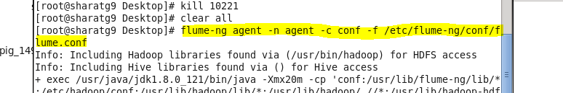
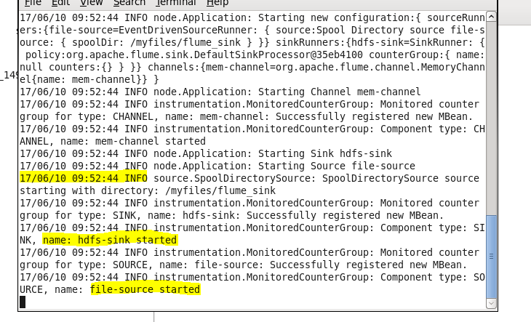
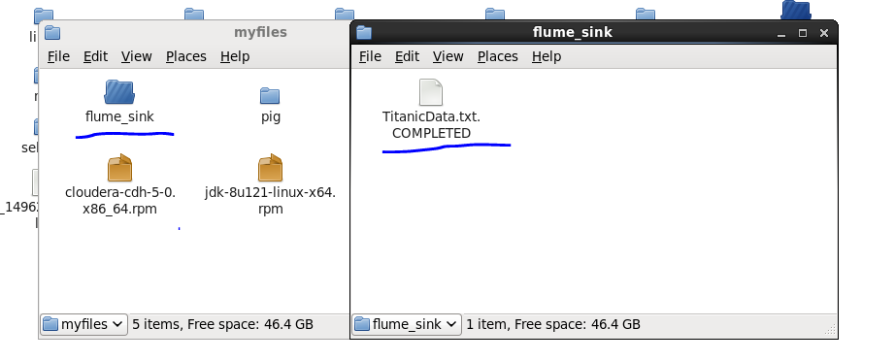
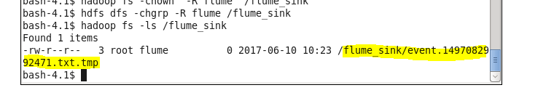
Copying the data set from local to HDFS using Flume agent
source path: /home/acadgild/project/flume_sink/
Target path: /user/flume_sink/

Flume conf file:
#Specify source, channel and sink
agent1.sinks = hdfs-sink1_1
agent1.sources = source1_1
agent1.channels = fileChannel1_1
#Flume Configuration Starts
# Define a file channel called fileChannel on agent1
agent1.channels.fileChannel1_1.type = file
# on linux FS
agent1.channels.fileChannel1_1.capacity = 200000
agent1.channels.fileChannel1_1.transactionCapacity = 1000
# Define a source for agent1
agent1.sources.source1_1.type = spooldir
# on linux FS
#Spooldir in my case is /home/hadoop/Desktop/flume_sink
agent1.sources.source1_1.spoolDir = /home/hadoop/project/flume_sink
agent1.sources.source1_1.fileHeader = false
agent1.sources.source1_1.fileSuffix = .COMPLETED
agent1.sinks.hdfs-sink1_1.type = hdfs
#Sink is /flume_import under hdfs
agent1.sinks.hdfs-sink1_1.hdfs.path = hdfs://localhost.localdomain:9000/user/flume_sink3
agent1.sinks.hdfs-sink1_1.hdfs.batchSize = 1000
agent1.sinks.hdfs-sink1_1.hdfs.rollSize = 268435456
agent1.sinks.hdfs-sink1_1.hdfs.rollInterval = 0
agent1.sinks.hdfs-sink1_1.hdfs.rollCount = 1500
agent1.sinks.hdfs-sink1_1.hdfs.writeFormat=Text
agent1.sinks.hdfs-sink1_1.hdfs.fileType = DataStream
agent1.sources.source1_1.channels = fileChannel1_1
agent1.sinks.hdfs-sink1_1.channel = fileChannel1_1

Start flume agent by the following command:
flume-ng agent -n agent1 -f spool_dir.conf

This will conform the agent is running and we can leave this terminal running at background

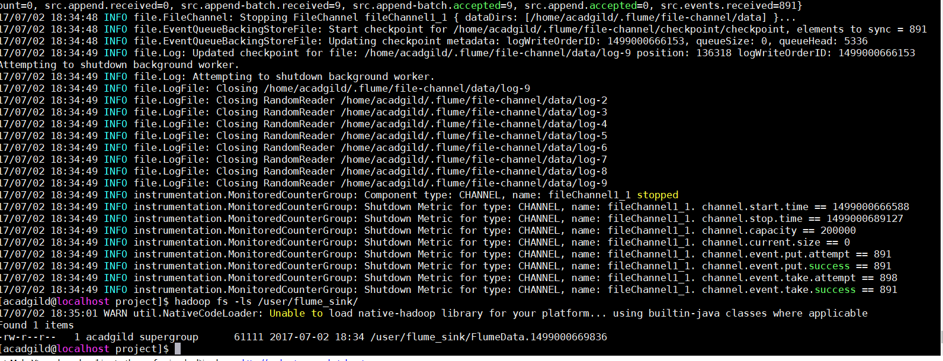
Completed file in Local marker as .Completed
As mentioned in flume configuration file TitanicData.txt is pasted inside flume_sink directory
We can now check the resultant temporary file inside HDFS at destination path generated by Flume. By the listing command we can find only one file inside '/user/flume_sink' directory

- Introduction
The data set contains information about passengers who boarded Titanic ship. It contains data
points like:
• Passenger’s age
• Their native place
• Details of who survived
• Fare details of various travel classes
• Number of casualties from various classes etc.
3. Prerequisites
You should have Hadoop cluster installed in your system.
4. Associated Data Files
https://drive.google.com/file/d/0ByJLBTmJojjzNmV0dk1EMmwwQ1U/view?usp=sharing
DATA SET DESCRIPTION
Column 1 : PassengerId
Column 2 : Survived (survived=0 & died=1)
Column 3 : Pclass
Column 4 : Name
Column 5 : Sex
Column 6 : Age
Column 7 : SibSp
Column 8 : Parch
Column 9 : Ticket
Column 10 : Fare
Column 11 : Cabin
Column 12 : Embarked
Big Data and Hadoop Development
ACADGILD Page 2
5. Problem Statement
You can use any of the technologies like Map Reduce, Pig or Hive of your choice.
Note:You need to copy the data set into HDFS using flume and send the screen shot of that with the
project solution

Approach used :
Program : hive

Creating table titanic ;
hive> create table titanic
> (PassengerId int,Survived int,Pclass int,Name string,Sex string,Age int,sibsp int,Parch int,Ticket string,Fare float,Cabin string,
> Embarked string)
> row format delimited fields terminated by ',' lines terminated by '\n' stored as textfile;

Table description:
Desc titanic;
loading data into hive table from file /user/flume_sink/FlumeData.1499000669836
Command:
load data inpath '/user/flume_sink/FlumeData.1499000669836' overwrite into table titanic_data;

1.In this problem statement we will find the average fare of each class.

Hive command:
select pclass,sum(fare)/count(*) from titanic_data group by pclass;
comments:
Average fare is calculated by applying the sum()/count(*) function on fare column along with applying group by on Pclass to in find the average fare of each class
snapshot:
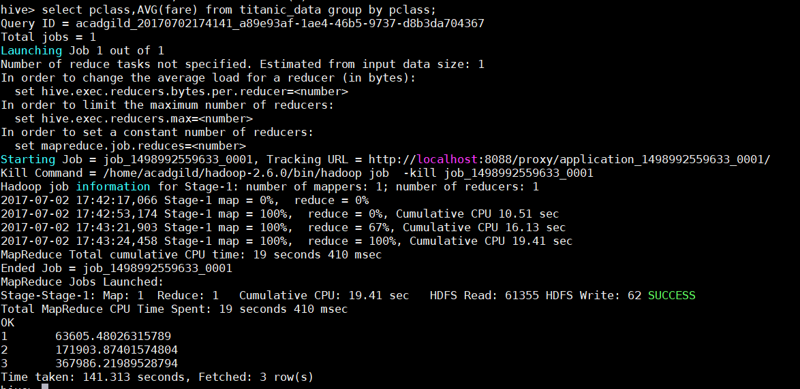
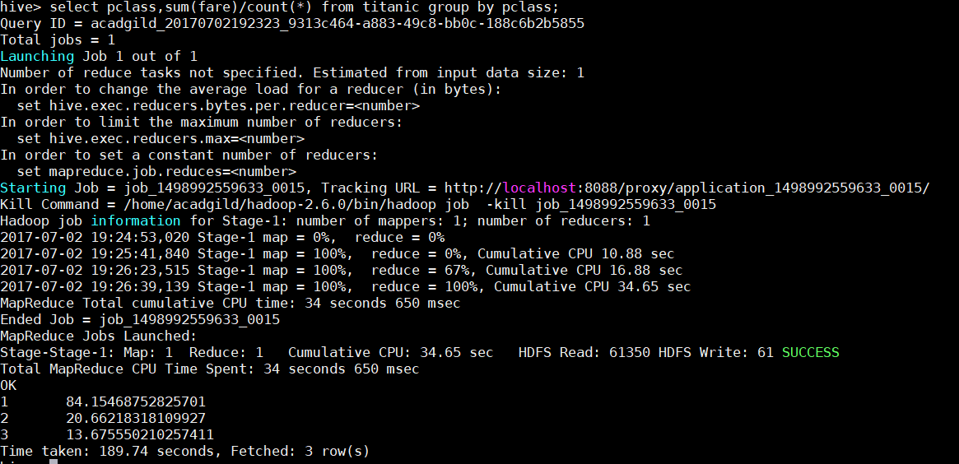
2.In this problem statement we will find the number of people alive in each class and
are embarked in Southampton.

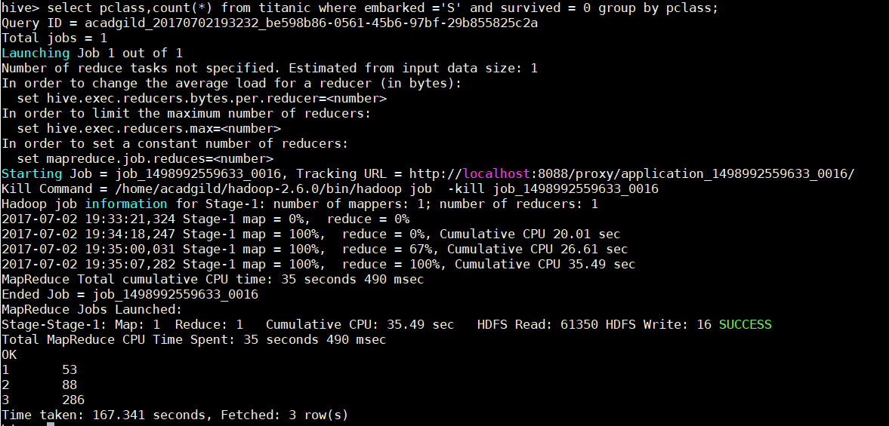
Comments:
the people embarked from southampton and survived is calculated by embarked ='S' and survived = 0 filter in where class

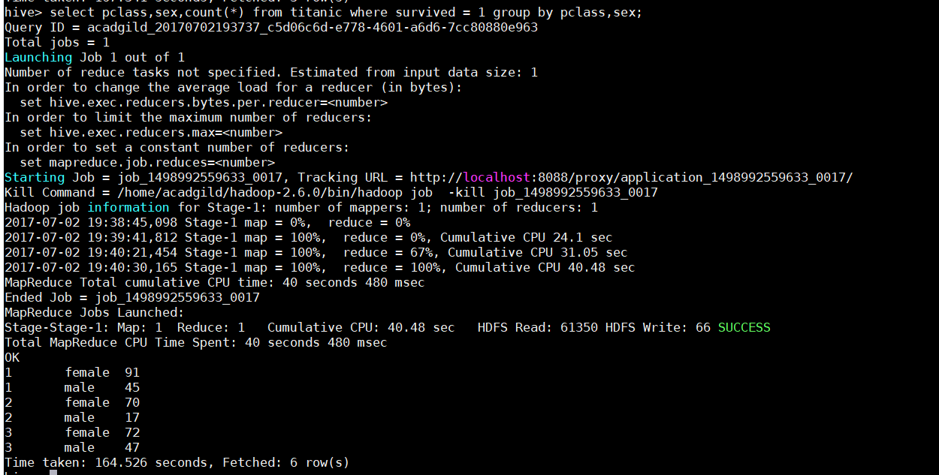
3.In this problem statement we will find out number of male and female people died in
each class.
Comments:
The people died caln be filtered by Survived = 1
and to find male and female people died in each class by applying group by on sex and pclass

All the problems statements mentioned in project has been sucessfully executed

.

